**­­­**

Class 8

**Lecture \***

**Digital Electronics**

**(Number System- Conversion-I)**

**Digital Electronics**



**Lab Objectives:**

* Number System Conversion-I.

**Number System Conversions**

There are three types of conversion:

**Decimal Number System to Other Base**

[for example: Decimal Number System to Binary Number System]

**Other Base to Decimal Number System**

[for example: Binary Number System to Decimal Number System]

**Other Base to Other Base**

[for example: Binary Number System to Hexadecimal Number System]

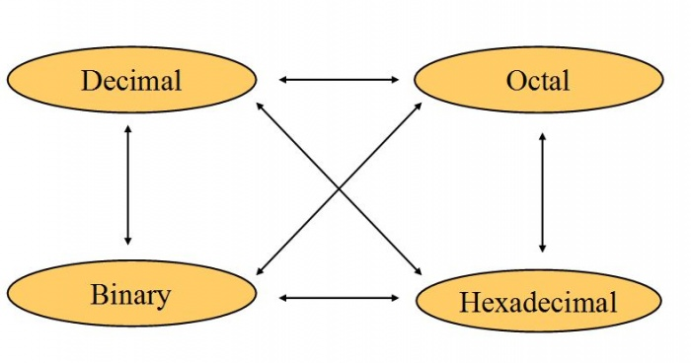

### Decimal Number System to Other Base

To convert Number system from Decimal Number System to Any Other Base is quite easy. you have to follow just two steps:

A) Divide the Number (Decimal Number) by the base of target base system (in which you want to convert the number: Binary (2), octal (8) and Hexadecimal (16)).

B) Write the remainder from step 1 as a Least Signification Bit (LSB) to Step last as a Most Significant Bit (MSB).

**Decimal to Binary Conversion**

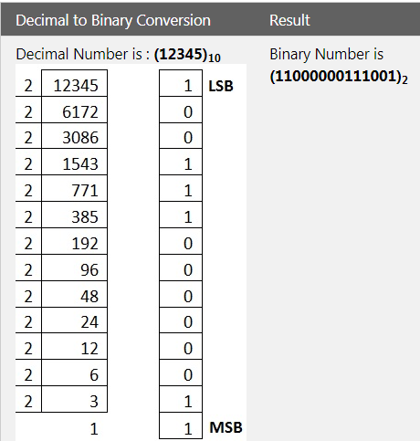

**Decimal to Octal Conversion**

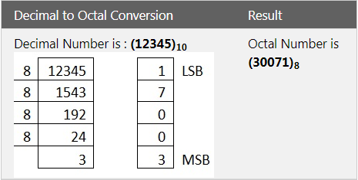

**Decimal to Hexadecimal Conversion**

